FOR IMMEDIATE RELEASE
BELL & CARLSON INTRODUCES NEW
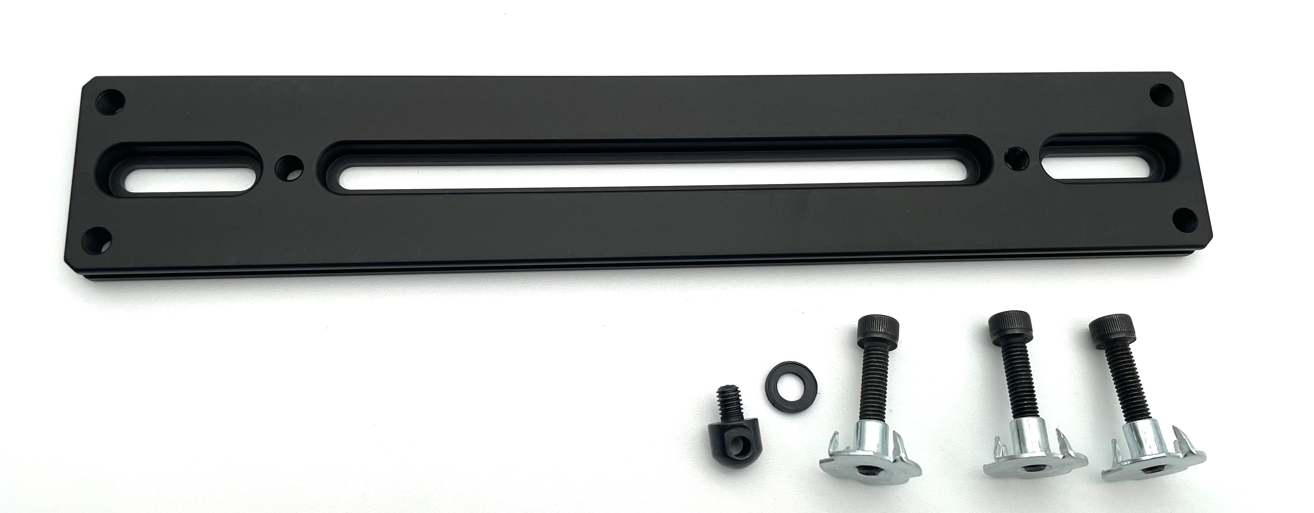8.5" UNIVERSAL ARCA RAIL #0090-00
A versatile, American-made mounting solution for hunters and precision shooters
— July 15, 2026 — Bell & Carlson has introduced its new 8.5-inch Universal ARCA Rail, designed to provide hunters, competitive shooters, and precision-rifle owners with a durable and adaptable mounting platform for compatible rifle stocks.
Built from hard-anodized aluminum, the rail provides a solid interface for ARCA-compatible bipods, tripods, barricade stops, and other shooting accessories. Its universal mounting layout features front and rear 1-inch mounting slots, along with a 4.9-inch center mounting slot, allowing flexibility across a variety of stock configurations and mounting positions.
“We wanted to offer shooters a practical ARCA rail that is strong, adaptable, and reasonably priced. The mounting slots provide flexibility, while the included hardware makes the rail ready for a wide range of rifle-stock applications.”

PRODUCT FEATURES
• 8.5-inch overall length
• Hard-anodized aluminum construction
• Front and rear 1-inch mounting slots
• 4.9-inch center mounting slot
• Stop-bolt holes at all four corners
• Includes three 10-32 x 7/8 mounting screws
• Includes three T-nuts, washer, and 10-32 sling stud
• Weight: 0.26 lb
• Made in the USA
PRICE AND AVAILABILITY: $47.50 plus shipping.
Orders and product information are available at www.BellAndCarlson.com or by calling 620-225-6688.
MEDIA CONTACT
Bell & Carlson
Phone: 620-225-6688
Website: www.BellAndCarlson.com

